Mount Dandenong Primary School  Farndons Road  Mount Dandenong 3767  03 9751 1136  mount.dandenong.ps@education.vic.gov.au  www.mtdandps.vic.edu.au | 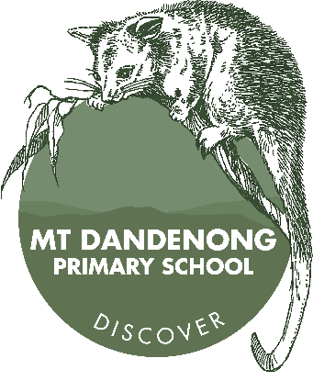

Dear parents and carers,

Welcome to Mount Dandenong Primary School where we value our unique environment and close community; a place for creative opportunities and academic excellence, nurturing respect, happiness, and independence. Our school enjoys a strong and unique sense of community. We believe that it takes a village to raise a child and that together we can ensure the success of all of our students from Foundation through to Year 6.

I feel very privileged to be able to work with the Mount Dandenong Primary School students, teachers and parent community to grow our vision for excellence in education together. In addition to developing a strong foundation in English and Mathematics, our students enjoy a rich and broad educational program including learning in Science, the Humanities, Technologies (including digital coding), the Arts (Visual, Dance and Drama), Health and Physical Education (including sport) and Japanese.

Our school has a reputation for excellence in the Arts and we are proud to offer additional opportunities for children to grow their creative passions and talents through instrumental music tuition, choir and participation in events such as Wakakirri. Our Wominjeka Community Garden with wood-fired pizza oven, play spaces and extensive grounds offer our students plenty of opportunities to explore nature and their environment, including growing produce for cookery and engaging in sustainable living.

I encourage you to visit our school website and download our fortnightly newsletter to keep abreast of all that is going on at our wonderful school.

Thank you for considering Mount Dandenong Primary School for your child’s primary school education. I hope to see you and your family back at the school soon so that you can discover what makes Mount Dandy such a special place to grow and learn.

Jake Laurie
Acting Principal

